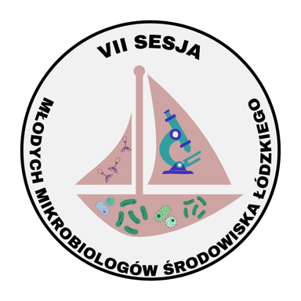
VII Sesja Młodych Mikrobiologów Środowiska Łódzkiego
(7th Session of Young Microbiologists from the Lodz Environment)
Lodz, June 14, 2024
PARTICIPATION REGISTRATION CARD

Name and surname:

Academic degree/title:
Select one.
Academic unit:
Select one.
Phone number:

E-mail address:

Abstract title:

Preferred form of presentation*:
☐ Oral presentation
☐ Poster
*the organizers reserve the right to change the form of presentation
Authors:

Area of interest:
☐ Environmental and general microbiology
☐ Microbiology in medicine
☐ Microbiology in industry

